**DATA ANALYTICS ASSIGNMENT 1**

MUKKAPATI MOULIKA

20NN1A0528

4th B.Tech (CSE)

VNITSW

**BAR CHART**

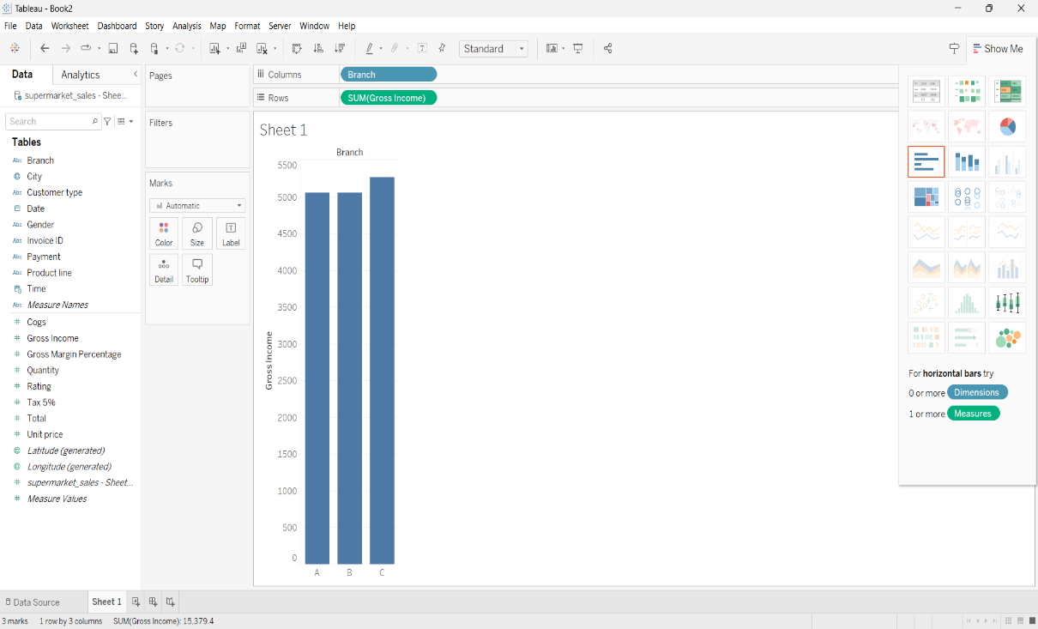

**PIE CHART** 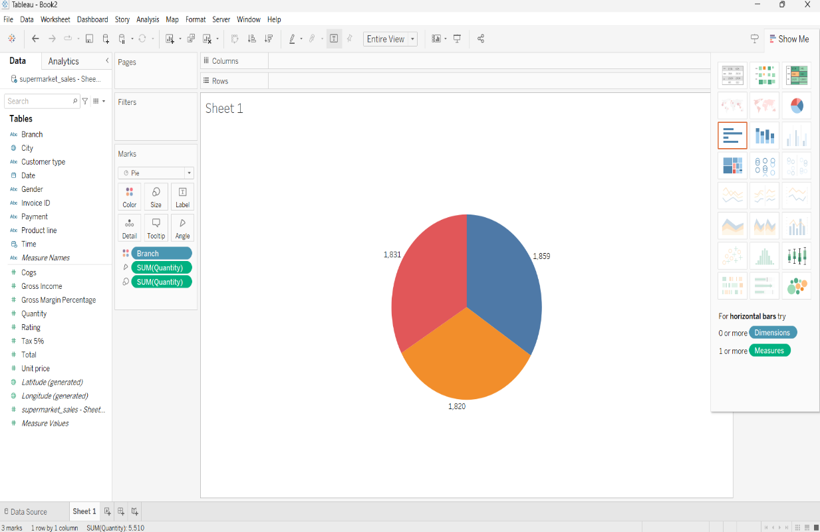

**STACKED BAR CHART**

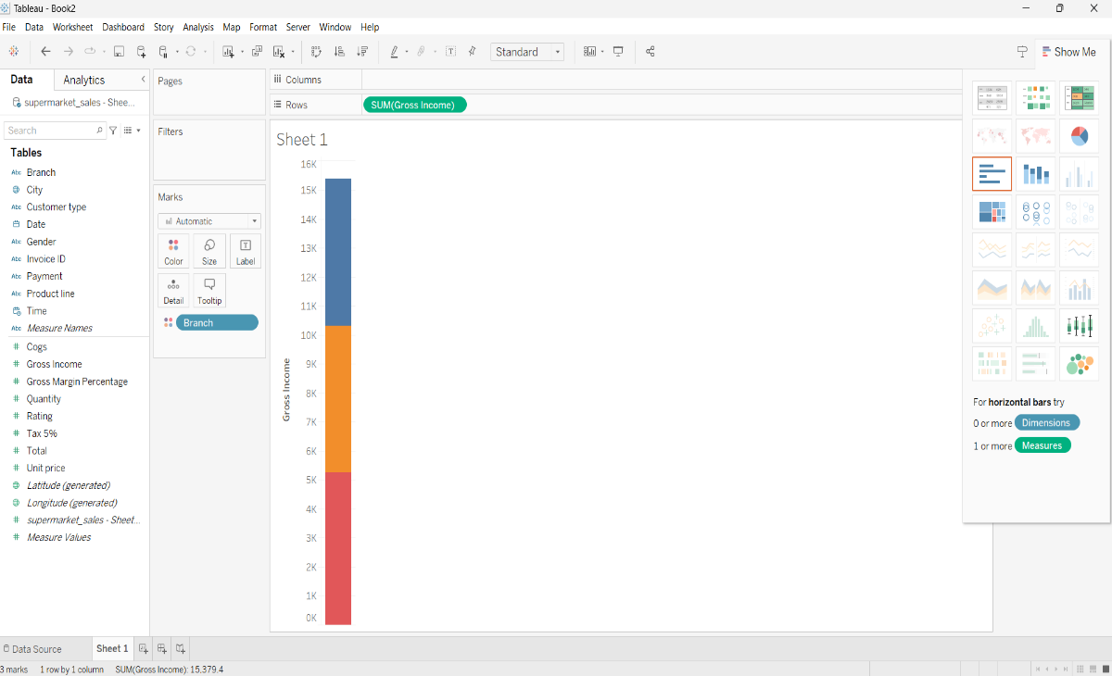

**LINE CHART**

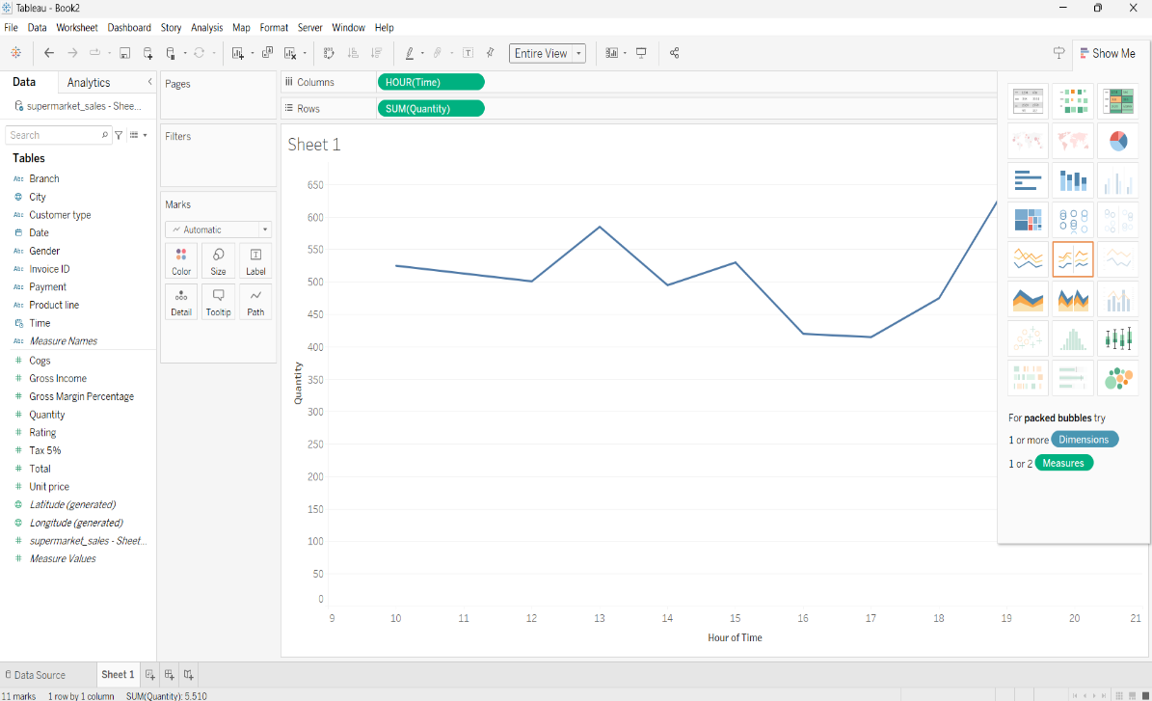

**BUBBLE CHART**

